Question : 1
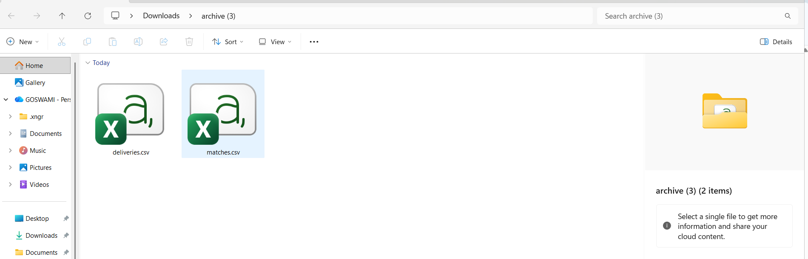
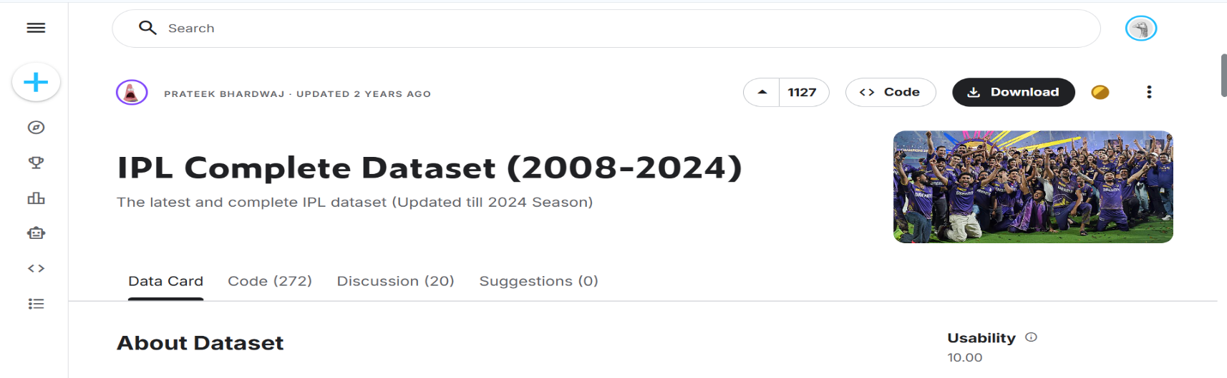
Download a sample CSV file of IPL cricket match scores from Kaggle or any public dataset, and use pd.read_csv() to load it into a DataFrame. Print the first 5 rows to verify the data :
import pandas as pd
df = pd.read_csv("matches.csv")
print(df.head())
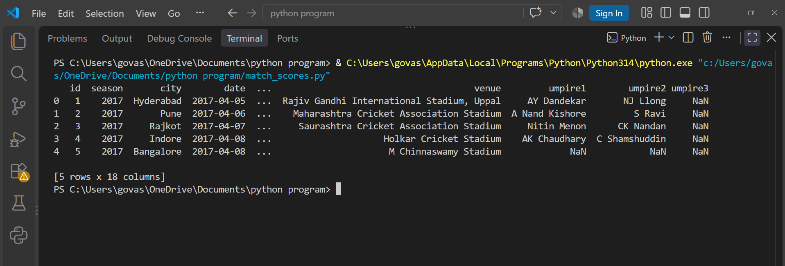

Question : 2
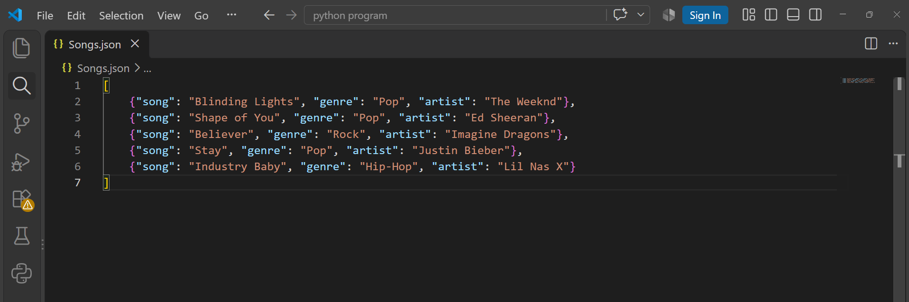
Find a small JSON dataset of trending songs (for example, from Spotify's API samples or any open JSON file), and use pd.read_json() to import it into a DataFrame. Display the DataFrame's column names and data types using df.info() :
import pandas as pd
df = pd.read_json("songs.json")
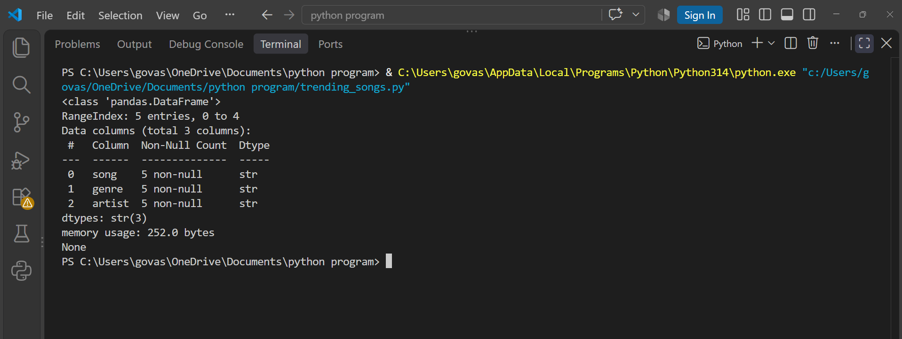
print(df.info())

Question : 3
You have a TSV (tab-separated values) file containing Zomato restaurant data. Use pd.read_csv() with the correct separator to load the data, and then use df.describe(include='all') to generate summary statistics.<br><br><em><strong>Hint:</strong> The separator for TSV files is '\t' : </em>

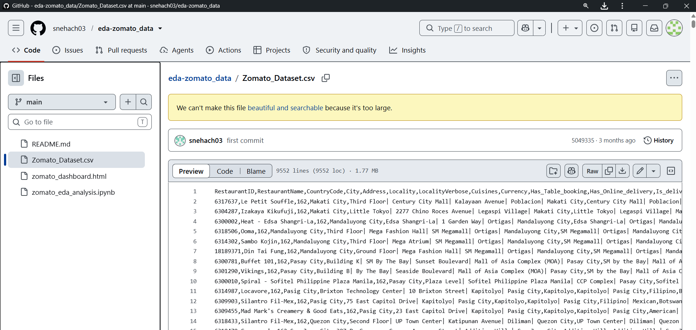
import pandas as pd
df = pd.read_csv("Zomato_Dataset.csv")
df.to_csv("Zomato_Dataset.tsv", sep="\t", index=False)
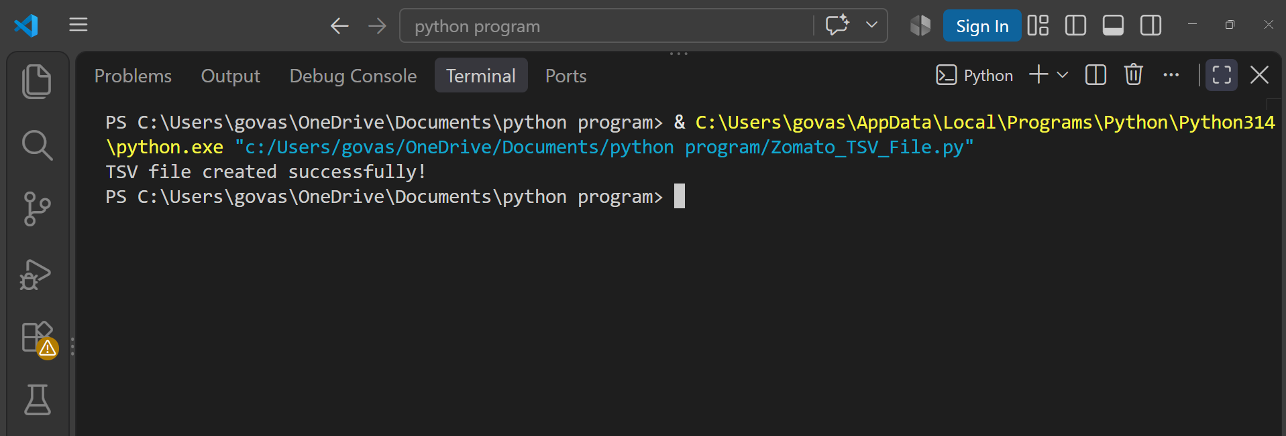
print("TSV file created successfully!")
import pandas as pd
df = pd.read_csv("Zomato_Dataset.tsv", sep="\t")
print(df.describe(include="all"))
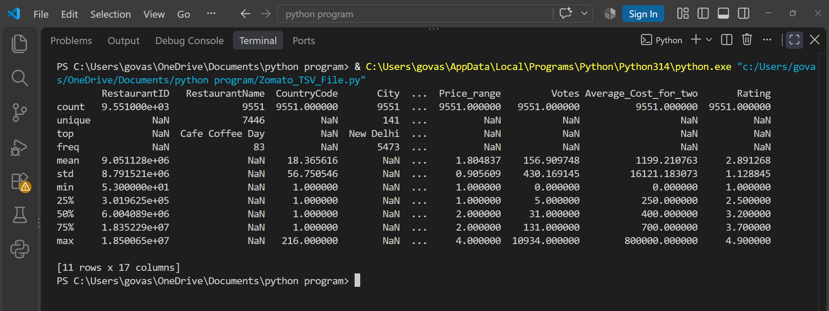

Question : 4
Download a large Excel file (at least 10,000 rows) of Flipkart product listings. Use pd.read_excel() with the chunksize parameter to read the file in chunks of 2000 rows, and print the number of rows in each chunk as you iterate :


import pandas as pd
csv_file = "marketing_sample_for_flipkart.csv"
chunk_size = 2000
print("Reading CSV file in chunks of 2000 rows:\n")
for chunk_number, chunk in enumerate(
pd.read_csv(csv_file, chunksize=chunk_size, on_bad_lines='skip'),
start=1 ):
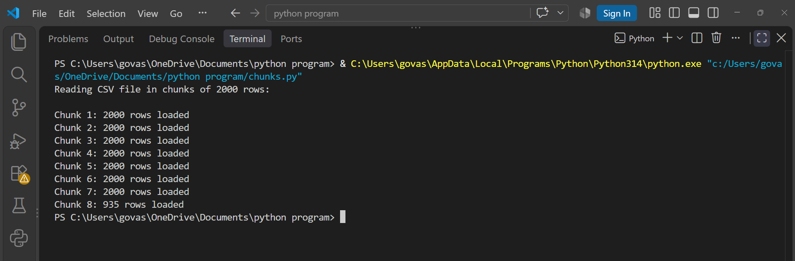
print(f"Chunk {chunk_number}: {len(chunk)} rows loaded")
Question : 5
Use ChatGPT or Copilot to generate a Python code snippet that reads a semicolon-separated CSV of Paytm transactions, detects missing values, and prints out which columns have nulls. Test the code with a small sample file and fix any errors you encounter :
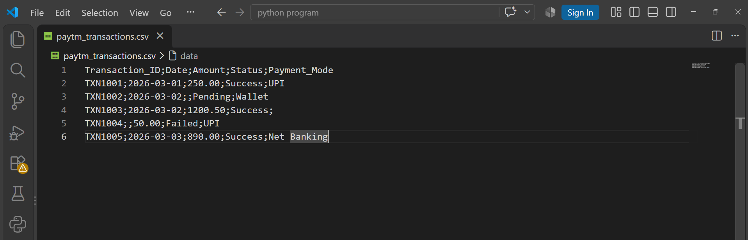
import pandas as pd
file_path = "paytm_transactions.csv"
try:
df =pd.read_csv(file_path, sep=";")
print("Dataset Loaded Successfully!\n")
print(df)
print("-" * 50)

# Detect missing values per column
missing_counts = df.isnull().sum()
# Filter columns that contain null values
cols_with_nulls = missing_counts[missing_counts > 0]
if not cols_with_nulls.empty:
print("Columns with missing (null) values:")
for column, count in cols_with_nulls.items():
print(f"- {column}: {count} missing value(s)")
else:
print("No missing values found in the dataset.")

except FileNotFoundError:
print(f"Error: The file '{file_path}' was not found. Please verify the file path.")
except pd.errors.ParserError as e:
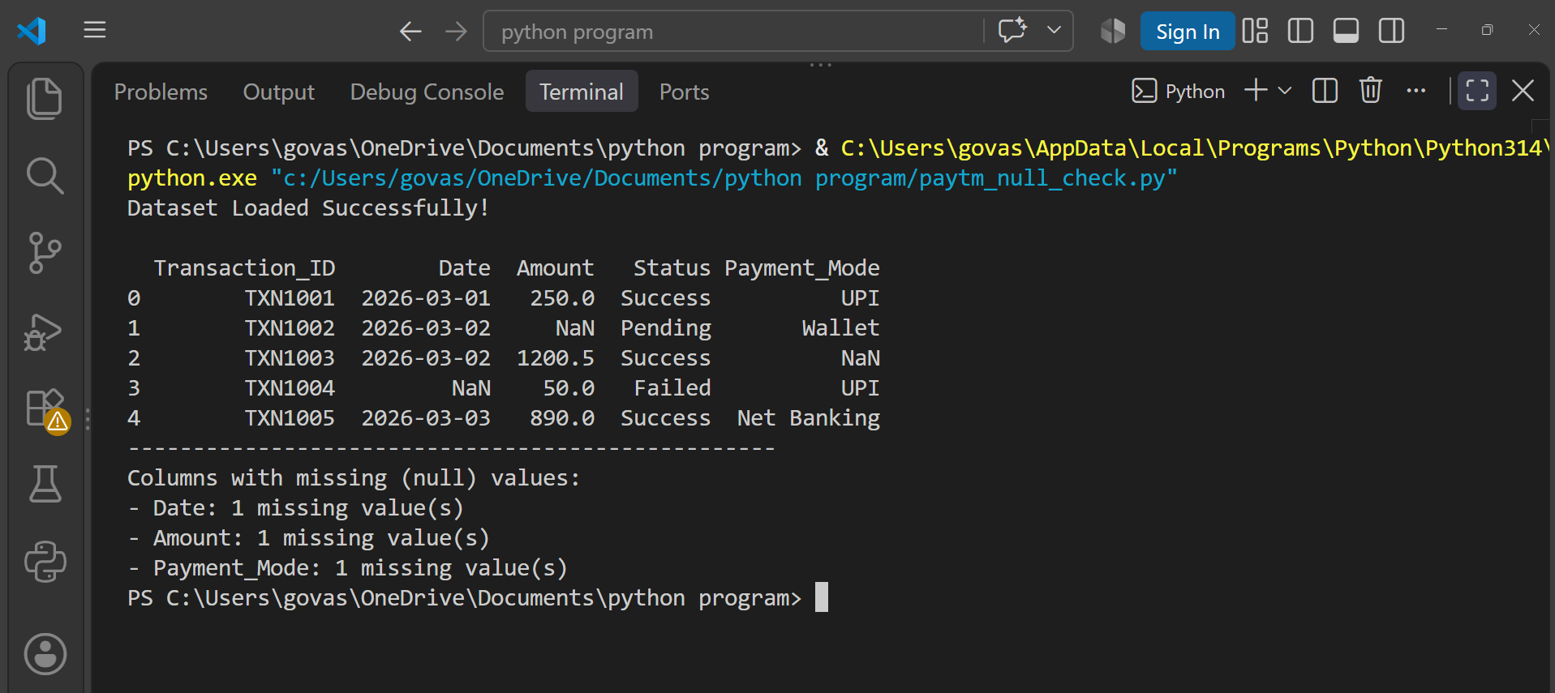
print(f"Parser error occurred: {e}")

